Year R Half Term Overview – Spring 1 2025
Area of Learning |  | Week 1  6th Jan | Week 2  13th Jan | Week 3  20th Jan |  | Week 4  27th Jan | Week 5  3rd Feb | Week 6  10th Feb
Literacy | Literacy Tree Text | 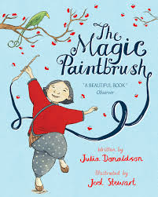  The Magic Paintbrush  Julia Donaldson |  |  |  | 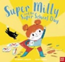  Super Milly and the Super School Day  Stephanie Clarkson
 | Phonics  Junior Learning  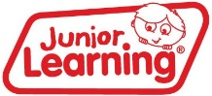 | 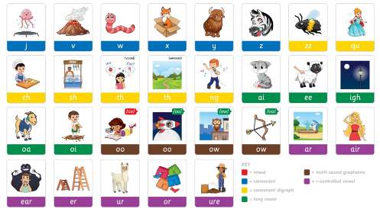  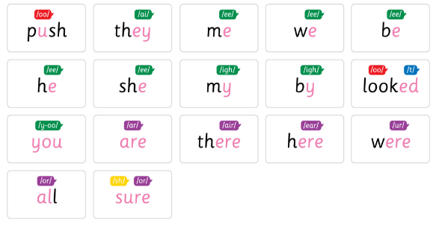  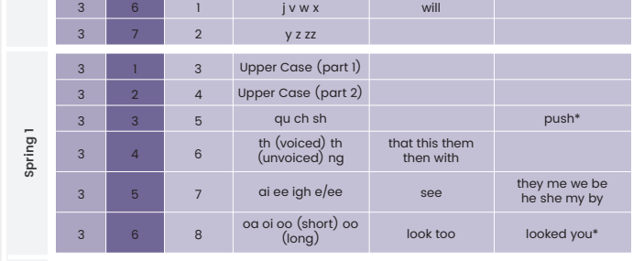
Maths | White Rose Maths   | Alive in 5  Step 1 Introduce zero  Step 2 Find 0 to 5  Step 3 Subitise 0 to 5  Step 4 Represent 0 to 5  Step 5 1 more  Step 6 1 less  Step 7 Composition  Step 8 Conceptual subitising to 5 |  | Mass and capacity  Step 1 Compare mass  Step 2 Find a balance  Step 3 Explore capacity  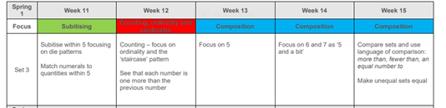  Step 4 Compare capacity |  | Growing 6, 7, 8  Step 1 Find 6, 7 and 8  Step 2 Represent 6, 7 and 8  Step 3 1 more  Step 4 1 less  Step 5 Composition of 6, 7 and 8  Step 6 Make pairs-odd and even  Step 7 Double to 8 (find a double)  Step 8 Double to 8 (make a double)  Step 9 Combine 2 groups  Step 10 Conceptual subitising |  | Length, height and time  Step 1 Explore length  Step 2 Compare length  Step 3 Explore height  Step 4 Compare height
 | NCETM
Physical Development | Fine Motor and Gross Motor | Dough Disco  Weekly upper body strength exercise activities  Weekly busy fingers activities  Weekly sensory activities
 | PE in the Hall | Gymnastics  Exploring Shapes  Objective: Recognize and create different body shapes (tall, small, wide, narrow). | Gymnastics  Balancing Acts  Objective: Develop static and dynamic balance on different body parts. |  | Gymnastics  Rolling and Rotating  Objective: Experiment with safe rolling movements (log roll, egg roll). | Gymnastics  Jumping and Landing  Objective: Master basic jumping techniques and safe landings. | Gymnastics  Traveling in Style  Objective: Move creatively in different ways (crawling, skipping, hopping). | Gymnastics  Putting It All Together  Objective: Combine shapes, balances, rolls, jumps, and travels into a sequence.
Communication and Language |  | Poetry Basket – Popcorn /When the Spring Wind Blows / Carrot Nose / Furry Furry Squirrel  Introduce Helicopter Stories  WELCOMM activities  Attention Autism Activities – Stage 1 and 2  Adults to model in all areas of provision to expand new vocabulary and help children build relationships.
PSED | Jigsaw | Healthy Me  Lesson 1: The Healthy, Happy Me Recipe Book | Healthy Me  Lesson 2: Everybody's Body |  | Healthy Me  Lesson 3: We Like to Move It, Move It! | Healthy Me  Lesson 4: Food Glorious Food | Healthy Me  Lesson 5: Sweet Dreams | Healthy Me  Lesson 6: Keeping Clean
 | Science | Ice Experiments  Conduct a series of experiments in the classroom around ice. Encourage children to make predictions about what they think will happen, how to make sure the experiment is fair and discuss what the findings are.  - Melting race  - What floats on ice?  - Frozen treasure hunt |  |  |  | Winter and Seasonal Change  What is winter?  When is winter?  What will we see outside in winter? | 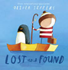 | 
 | Geography and History |  | 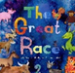 |  | Lunar New Year  Reception will look at the where and how families celebrate lunar new year. We will look at the importance of the lunar zodiac and learn about the year of the snake. Reception will look at music and dance that they may see during the festival and other crafts and foods that they may see. |  | Polar Lands  Learn about penguins, what they eat and their habitat and look at a globe together. | Polar Lands  Reception will find a lost penguin and will have to work out how to get it home using their penguin knowledge. Read the story of Lost and Found.
 | Design Technology  | Textiles: Bookmarks  Exploring threading and weaving  Paper Weaving  Sewing with hessian | Textiles: Bookmarks  Designing, Creating and Evaluating Bookmarks
EAD | Music  Sing Up!
Enrichment Opportunities |  |  |  |  |  |  |  | Penguin Waddle Fundraiser

